**Phase 9: Reporting, Dashboards & Security Review**

**Objective:**  
To create insightful visual reports and dashboards for the Smart Internship & Placement System, enabling HR and Placement teams to track internship applications and student placement status efficiently. Security settings were also reviewed to ensure appropriate data access.

**Reports Created**

**1. Applications per Internship**

**Purpose:**  
To track the number of student applications per internship and identify top hiring companies.

**Procedure:**

1. Navigated to **Reports → New Report**.
2. Selected **Applications (Application__c)** as the report type.
3. Set filters:
   * **Show:** All Applications
   * **Status:** Included Applied, Approved, Rejected, Selected
   * **Date Range:** All Applications (used Created Date as reference)
4. Grouped rows by **Internship Title**.
5. Grouped columns by **Status** to see breakdown of applications.
6. Added **Record Count** to summarize total applications per internship.
7. Saved the report as **Applications per Internship** in a **Public folder** accessible to HR users.  
     
     
   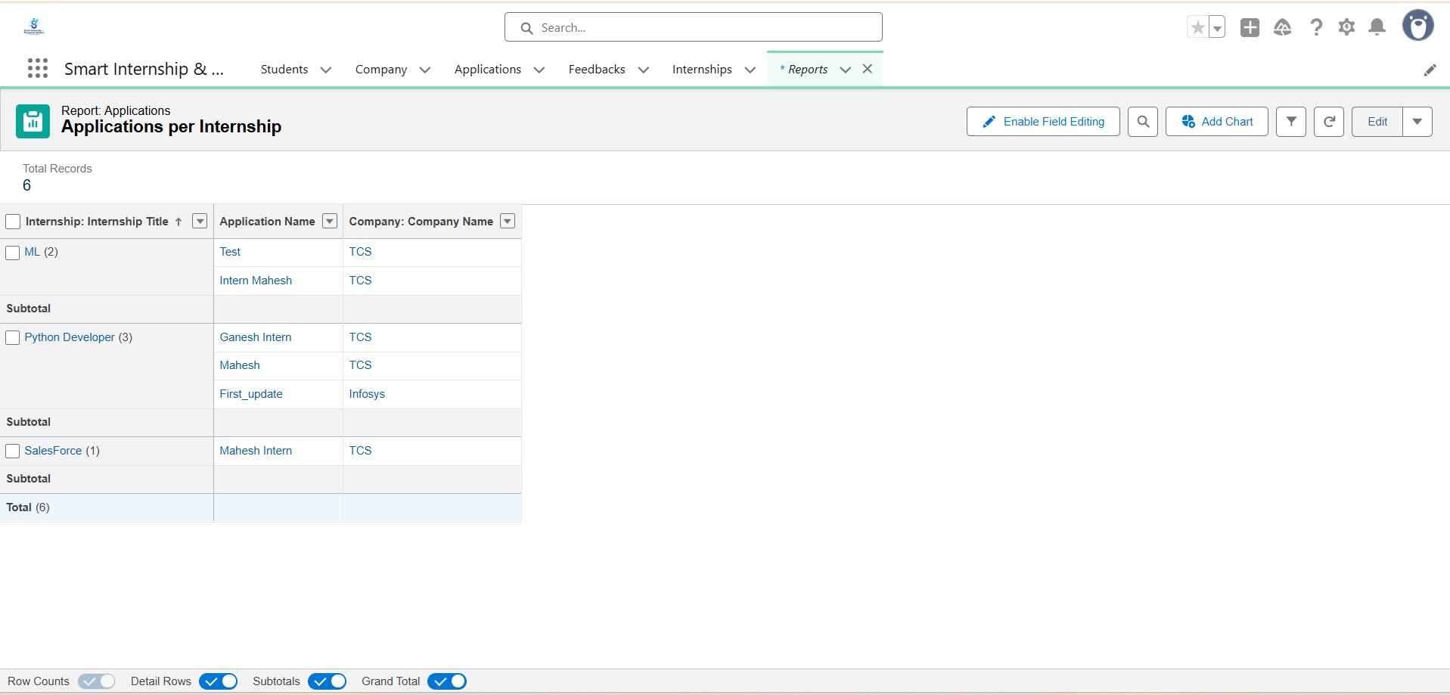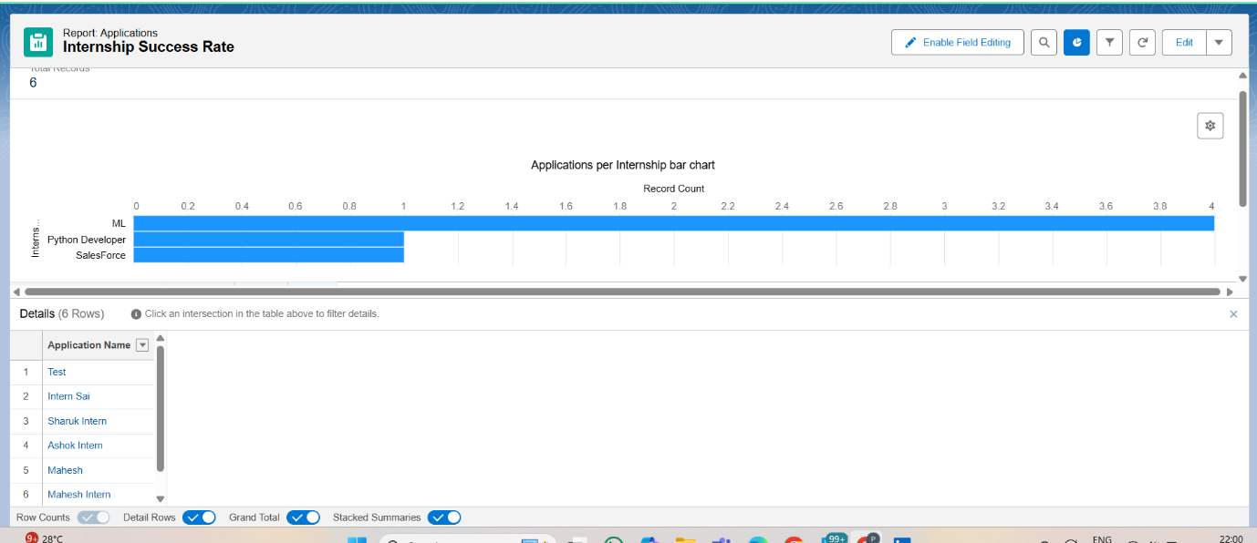

**Dashboard Creation**

**Objective:**  
To visually present key internship data for quick analysis by HR and Placement teams.

**Procedure:**

**Step 1 — Create Dashboard**

1. Navigated to **Dashboards → New Dashboard**.
2. Named the dashboard **Phase 9 Dashboard** and selected a **public folder**.
3. Clicked **Create**.

**Step 2 — Add Top Internships Bar Chart**

1. Clicked **+ Component** → selected **Bar Chart**.
2. **Data Source:** Applications per Internship report.
3. **X-Axis:** Company__c and Internship title(added to report as a row grouping for this purpose).
4. **Y-Axis:** Record Count (total applications).
5. Sorted descending to show companies with most applications first.
6. Titled the chart **Company Internship Hiring**.

**Step 3 — Add Student Placement Status Pie Chart**

1. Clicked **+ Component** → selected **Pie Chart**.
2. **Data Source:** Applications per Internship report.
3. **Slice By:** Status (Applied, Approved, Rejected, Selected).
4. **Measure:** Record Count.
5. Titled the chart **Top Internships Opportunities.**

**Step 4 — Arrange and Save**

1. Placed **Bar Chart** and **Pie Chart** neatly for clear visualization.
2. Clicked **Save → Done**.
3. Dashboard now displays:
   * Applications per internship by company
   * Student placement status distribution  
       
     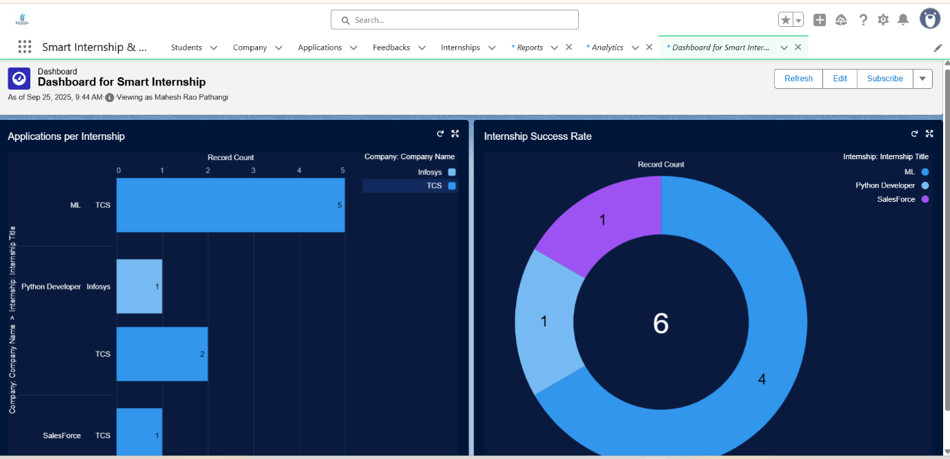

**Security Review**

1. Verified **Folder Access**: Reports and dashboard stored in a **Public folder** for HR and Placement profiles.
2. Confirmed **Field-Level Security** and **Object Permissions**:
   * Students could view only allowed fields.
   * HR could access all necessary report data.
3. OWD (Organization-Wide Defaults) reviewed and set appropriately to **Private** for sensitive objects.  
     
   